# **BANKING ANALYSIS OF MARKETING ANALYSIS**

**DATABASE Design**



 **CUSTOMER PLANS QUERIES**

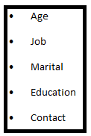 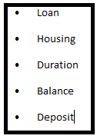 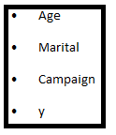

## **DATABASE DESIGN→**

| **age** |
| --- |
| **job** |
| **marital** |
| **education** |
| **default** |
| **housing** |
| **loan** |
| **contact** |
| **month** |
| **day_of_week** |
| **duration** |
| **campaign** |
| **pdays** |
| **previous** |
| **poutcome** |
| **emp.var.rate** |
| **cons.price.idx** |
| **euribor3m** |
| **nr.employed** |
| **y** |

## 

**The data contains 45 211 observations of 21 features, where are 10 categorical features and 7 numeric features.**

## 

## **DATABASE DESIGN AFTER ANALYSIS→**

## 

| **age** |
| --- |
| **job** |
| **marital** |
| **education** |
| **default** |
| **housing** |
| **loan** |
| **contact** |
| **month** |
| **day_of_week** |
| **duration** |
| **campaign** |
| **pdays** |
| **previous** |
| **poutcome** |
| **y** |

**Architecture diagram**









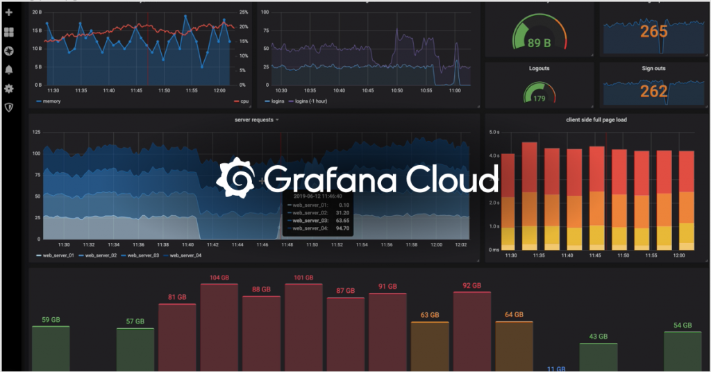

**UML Diagram**

**Use Case Diagram**

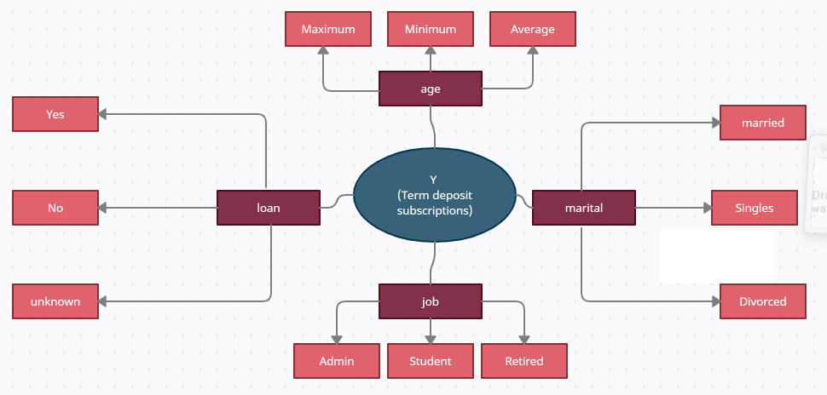

**Class Diagram:**

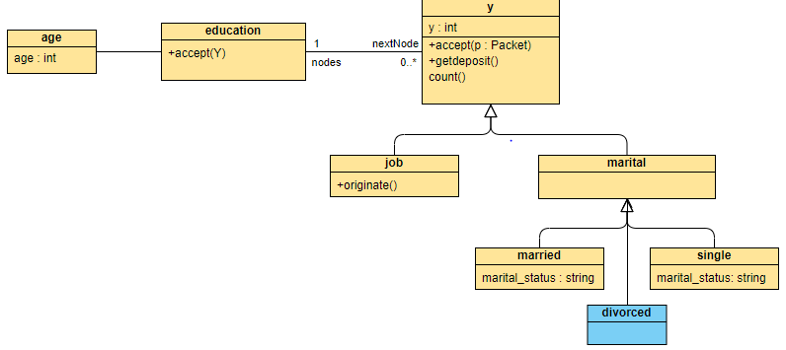

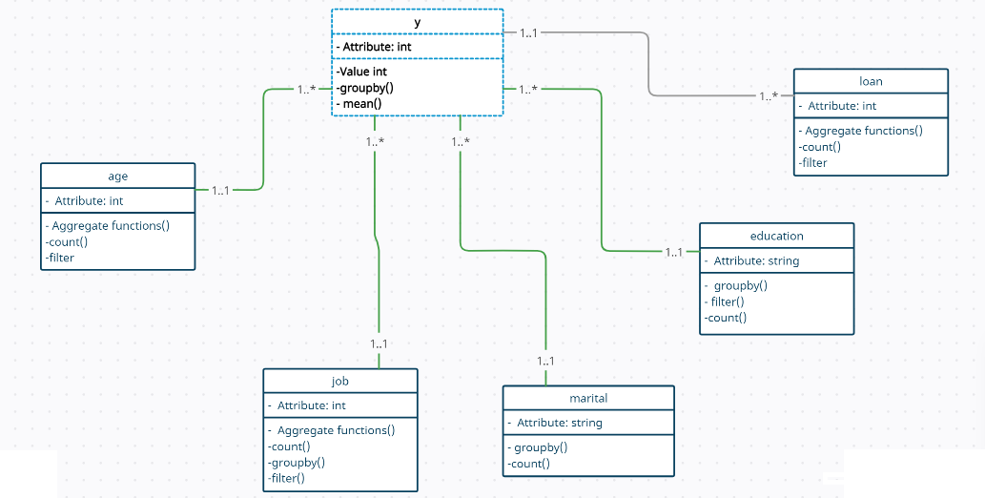

**TEAM D**

**Lasya Tlv**

**Sangeetha D**

**Santhosh. J**

**Shifana Tasneem M**